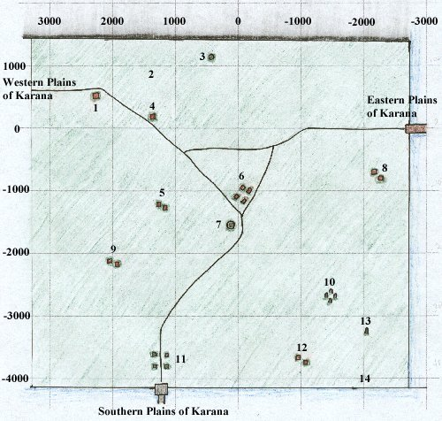

* 1. Hut with Alcohol
* 2. Area Patrolled by the Fangbreakers
* 3. Obelisk with named Treant nearby
* 4. Hut with Innkeepers selling Food and Goods
* 5. Empty farm
* 6. Gypsy Camp selling Combine Weapons, Alcohol, Food and Goods, Dreadlands Gate Spell, Bind Spot circa Mar 2001 [[2]](https://www.project1999.com/forums/showthread.php?t=337060)
* 7. Guard Tower
* 8. Farm with farmers
* 9. Farm with farmers
* 10. [Druid](https://wiki.project1999.com/Druid) Ring with Treants, [Druid](https://wiki.project1999.com/Druid) Trainer and merchant selling Druid Spells -2750,-1450
* 11. Wizard Teleportation Ring
* 12. Farm with farmers
* 13. Obelisk with Ghouls
* 14. Raider Camp

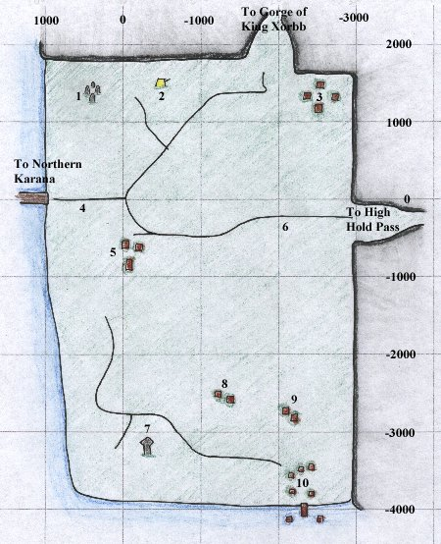

* 1. Druid Ring with [Druid](https://wiki.project1999.com/Druid) and Treant
* 2. Bandit Camp
* 3. Shops selling Weapons, Food, Goods, and Cloth Armor
* 4. [Sir Morgan](https://wiki.project1999.com/Sir_Morgan) (wanders east down the road and back)
* 5. Shops selling Archery Items and Food
* 6. Gnolls
* 7. Haunted Obelisk
* 8. Farm with farmers
* 9. Farm with farmers
* 10. [Barbarian](https://wiki.project1999.com/Barbarian) Fishing Village

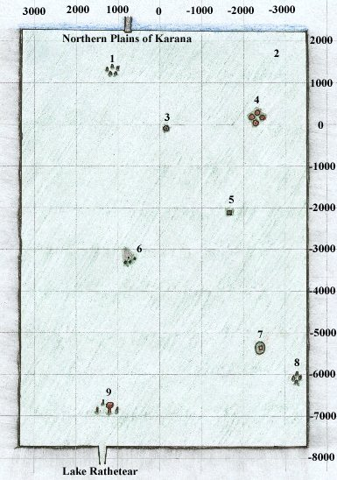

* 1. Undead Ruins with [Lord Grimrot](https://wiki.project1999.com/Lord_Grimrot)
* 2. Treants
* 3. [Vhalen Nostrolo](https://wiki.project1999.com/Vhalen_Nostrolo" \o "Vhalen Nostrolo)'s Well
* 4. Centaur Stables with Merchant selling Bowyer Supplies
* 5. Obelisk with Zombies
* 6. Entrance to [Splitpaw Lair](https://wiki.project1999.com/Splitpaw_Lair" \o "Splitpaw Lair)
* 7. Hermit House
* 8. Ruined Stone Ring
* 9. Aviak Town with Merchant [Krak Windchaser](https://wiki.project1999.com/Krak_Windchaser" \o "Krak Windchaser) (Top of Bird House)
* ([-5600, +150](https://wiki.project1999.com/South_Karana) [Map Icon.png](https://wiki.project1999.com/File:Map_Icon.png)) North-East of Aviak Town (#9): [High Shaman Grisok](https://wiki.project1999.com/High_Shaman_Grisok) or [High Shaman Phido](https://wiki.project1999.com/High_Shaman_Phido) or PH (for the [Monk Headband Quests](https://wiki.project1999.com/Monk_Headband_Quests)); spawn time is roughly 22 minutes

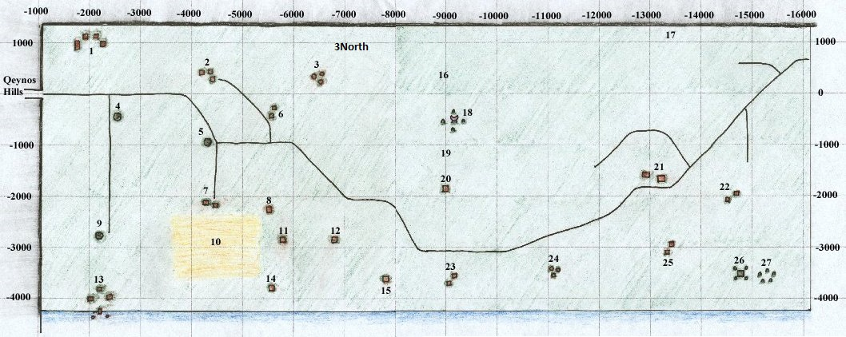1. Shops selling Cloth Armor, Cooking Supplies, Clay and Firing Sheets

* 2. Shops selling Throwing Daggers and Tailoring Patterns. [Innkeep Rislarn](https://wiki.project1999.com/Innkeep_Rislarn" \o "Innkeep Rislarn) selling Food
* 3. Bandit Camp (Bandits: Level 9-11). Note there is also a bandit camp ("3 North") just north and slightly east of Camp 3, near (890, -7050)
* 4. Guard Tower ("Tower 1")
* 5. Guard Tower ("Tower 2")
* 6. Farm taken over by Bandits and a Brigand (Bandits: Level 9-11)
* 7. Cleet Miller Farm
* 8. Empty farm
* 9. Guard Tower
* 10. Fields with Scarecrows (Undead Level 12-17)
* 11. Henina Miller Farm with Furball, also sells items
* 12. Empty farm
* 13. [Barbarian](https://wiki.project1999.com/Barbarian) Village selling Large Blacksmithing Molds and Books, Shaman Summon Spells
* 14. Tiny Miller's House
* 15. Farm with ex-Druid, Linaya Sowlin
* 16. Mountains filled with Bandits (Bandits: Level 9-11; the map makes it look more to the West than it is; loc is closer to 900, -11500)
* 17. Caninel with Gnoll Allies
* 18. Ogre Shrine guarded by [Ogre Guards](https://wiki.project1999.com/An_ogre_guard_(Karana)), [Ogre shamans](https://wiki.project1999.com/An_Ogre_Shaman) (ph's for, [An Ogre Priestess](https://wiki.project1999.com/An_Ogre_Priestess) & [Chief Goonda](https://wiki.project1999.com/Chief_Goonda)) (Ogres: Level 20-27 | Chief Level 34) respawns 22 minutes
* 19. [Froon](https://wiki.project1999.com/Froon" \o "Froon) and [Choon](https://wiki.project1999.com/Choon" \o "Choon) on a hill
* 20. Barbarian shop selling Fletching Kit, Arrows, Bows, and Nocks,
* 21. Shops selling [Blacksmithing](https://wiki.project1999.com/Skill_Blacksmithing) Books and Molds, also [Innkeep Danin](https://wiki.project1999.com/Innkeep_Danin" \o "Innkeep Danin) selling Food
* 22. Farms
* 23. Farms
* 24. Bandit Camp
* 25. Farms with Poison Merchant
* 26. Pyramid (Wizard portal)
* 27. Undead Ruins

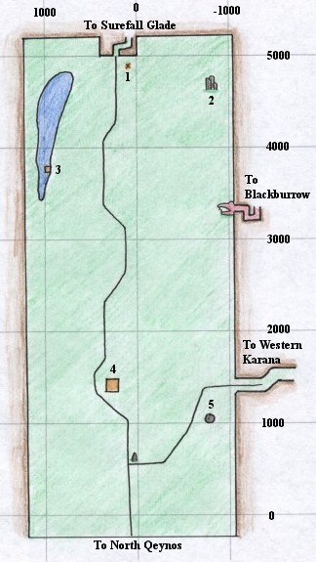

* 1. The Millers' Fire
* 2. The Haunted Ruins
* 3. [Hadden](https://wiki.project1999.com/Hadden" \o "Hadden) (6 hour Respawn) - chance to drop [Fishbone Earring](https://wiki.project1999.com/Fishbone_Earring)
* 4. Hut which sells [Smithing](https://wiki.project1999.com/Smithing" \o "Smithing) Books, Medium Armor Molds, Sectional Molds, and other smithing Molds, Sheet Metal
* 5. Guard Tower

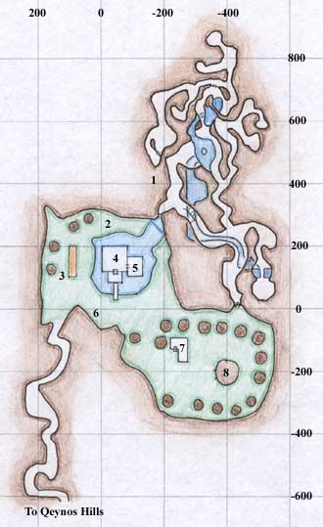

* Surefall Glade
* 1. The Caves filled with Bears and Mammoth
* 2. [Ranger](https://wiki.project1999.com/Ranger) Trainer
* 3. Archery Range with Ranger Trainer and Merchant who sells [Arrow-making](https://wiki.project1999.com/Skill_Fletching) Supplies
* 4. Ranger Hall with Ranger Guildmaster and Bard
* 5. Shop with Ranger Trainer and Merchants who sell [Bow-making](https://wiki.project1999.com/Skill_Fletching) Supplies, Bows, Throwing Weapons, Spells, Sharp Weapons, Food and Other Goods
* 6. Merchant selling Basic [Smithing](https://wiki.project1999.com/Skill_Blacksmithing" \o "Skill Blacksmithing) Molds
* 7. Jaggedpine Treefolk with Druid Trainer and Merchants who sell Arrow-making Supplies, Druid Weapons, Spells, Food and Other Goods
* 8. [Druid](https://wiki.project1999.com/Druid) Guildmaster and Surefall Druid Teleport destination

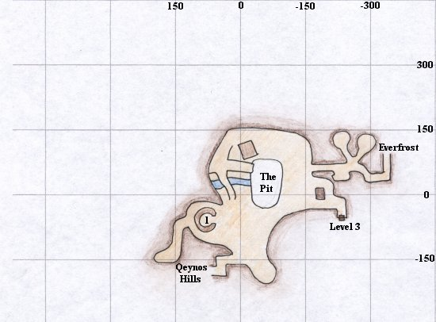

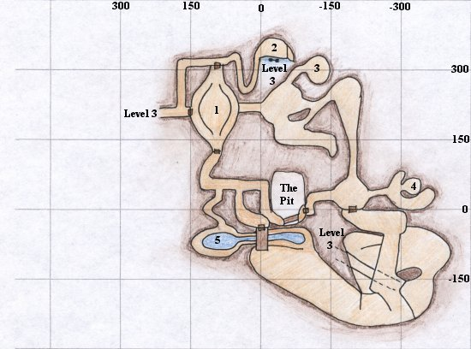

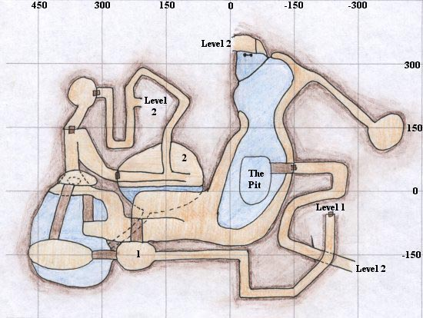

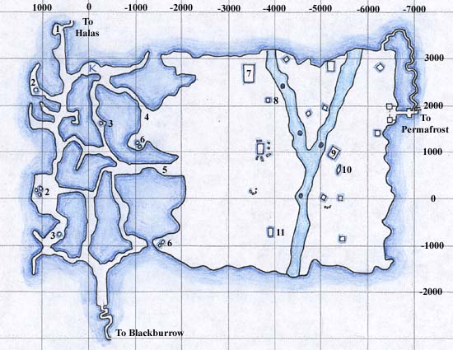

**Everfrost**

* 1. Merchants selling Large Sewing Kits, Sewing Supplies, and Goods
* 2. Ice Goblin Igloos with low-level spawns
* 3. Ice Goblin Igloos
* 4. [Barbarian](https://wiki.project1999.com/Barbarian) Guards
* 5. Bandl McMarrin -- Barbarian Guard
* 6. Ice Goblin Igloos with mid-level spawns
* 7. Temple with Barbarian Shaman selling Poison-based Spells
* 8. "North Tower" or "Megan's Tower"
* 9. Temple inhabited by Icy Orcs and [Redwind](https://wiki.project1999.com/Redwind" \o "Redwind)
* 10. Stone Giant Statue
* 11. "South Tower"

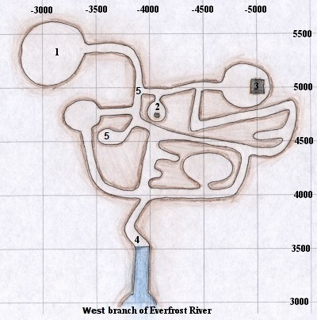

**Bear Caves**

* 1. Room with [Sulon McMoor](https://wiki.project1999.com/Sulon_McMoor" \o "Sulon McMoor), high level Necromancer
* 2. Ice Boned Skeletons with broken Teleporter
* 3. Ice Boned Skeletons in Building with Wizard Rod piece on ground
* 4. Entry Room with Ice Goblins
* 5. [a glacier bear](https://wiki.project1999.com/A_glacier_bear) spawn point

Winds of Karana

[**Classic Era**](https://wiki.project1999.com/Category:Classic_Era)([added 1999-2000](https://wiki.project1999.com/EverQuest_Timeline))

|  |  |
| --- | --- |
| **Start Zone:** | [Northern Karana](https://wiki.project1999.com/Northern_Karana) |
| **Quest Giver:** | [Vhalen Nostrolo](https://wiki.project1999.com/Vhalen_Nostrolo) |
| **Minimum Level:** | 20 |
| **Classes:** | All |
| **Related Zones:** | [Southern Karana](https://wiki.project1999.com/Southern_Karana) |
| **Related NPCs:** | [Cordelia Minster](https://wiki.project1999.com/Cordelia_Minster), [a hermit](https://wiki.project1999.com/A_hermit) |

Reward

* [Song: Jaxan's Jig o' Vigor](https://wiki.project1999.com/Jaxan%27s_Jig_o%27_Vigor)

Walkthrough

This quest starts with [Vhalen Nostrolo](https://wiki.project1999.com/Vhalen_Nostrolo" \o "Vhalen Nostrolo). Completed by an Agnostic Dark Elf Wizard with apprehensive faction.

You say, 'Hail, Vhalen'

Nice to meet you. Do not the plains of Karana about with life? This land is truly blessed by the gods. Would you like to hear a tune or will you pass up the opportunity?

You say, 'I would like to hear a tune.'

Inside this heart, I am trapped with the sight of beautiful colors, all memories of your love. They attack me with full might. You left me here in this garden of grey Never to see the true colors of the happiness of day Here in my hear I sit and I cry. You have left me alone and my colors have all died.... What do you think? Is it a happy tune or a sad tune?

You say, 'It is a sad tune.'

It takes a broken heart to truly appreciate that tune. I'm glad you enjoyed it. My dear Metala left me one year ago. The wound was healed, but the scar remains. I am presently trying to complete a new composition. Maybe that will turn me around.

You say, 'What new composition?'

I have come here to create my greatest composition. I call it 'The Winds of Karana'. Alas, the song sheets have been taken from me. While I, ahem, attended to some personal business, a hermit came and stole two song sheets from my pack. It would be grand if, in your journeys, you were to come upon this hermit of the plains and return my song sheets to me. I would pay dearly. Now, I must get back to my thoughts. Please excuse me.

Now, head southeast till you see a cottage. It has a hexagonal wall of stone surrounding it, so it's not hard to find. Inside the walls is [**a hermit**](https://wiki.project1999.com/A_hermit). A very unfriendly sort. The door to the hermits house is either locked, or broken and won't open. So it's hard to get to him.

The easiest way to get him out is to stand behind the hut and say "I'm here to kill you." You can also try to target him and attack him. After he is dead, his body will contain the [Cracked Flute](https://wiki.project1999.com/Cracked_Flute), [Winds of Karana sheet 1](https://wiki.project1999.com/Winds_of_Karana_sheet_1) or just one or the other.

Kill the hermit until you loot a flute, and a sheet music page.

The second piece is in the hands of [Cordelia Minster](https://wiki.project1999.com/Cordelia_Minster).

You say, 'Hail, Cordelia'

I can not find my flute, my favorite possession. Is there anyone who can [help] me?

You say, 'How can I help?'

My flute is missing, I think that old dirty hermit took off with it. He is always taking off with my things.

When you hand her the flute from the hermit...

Why thank you, kind adventurer! Here is a little something to keep food in your belly. Now back to practice. La la la..

**You gain experience!!**

You receive 1 silver

You receive [Winds of Karana sheet 1](https://wiki.project1999.com/Winds_of_Karana_sheet_1).

Now that you have both pages of sheet music, go back to Vhalen and give them both to him.

Thank you, my friend. I have just completed the composition. It is a work of art. Here. Have a copy. I hope you have the musical talent required to play it. If not.. Practice, practice, practice!

**You gain experience!!**